Model-Based Reflex Agent

Python.file:

Screenshot:

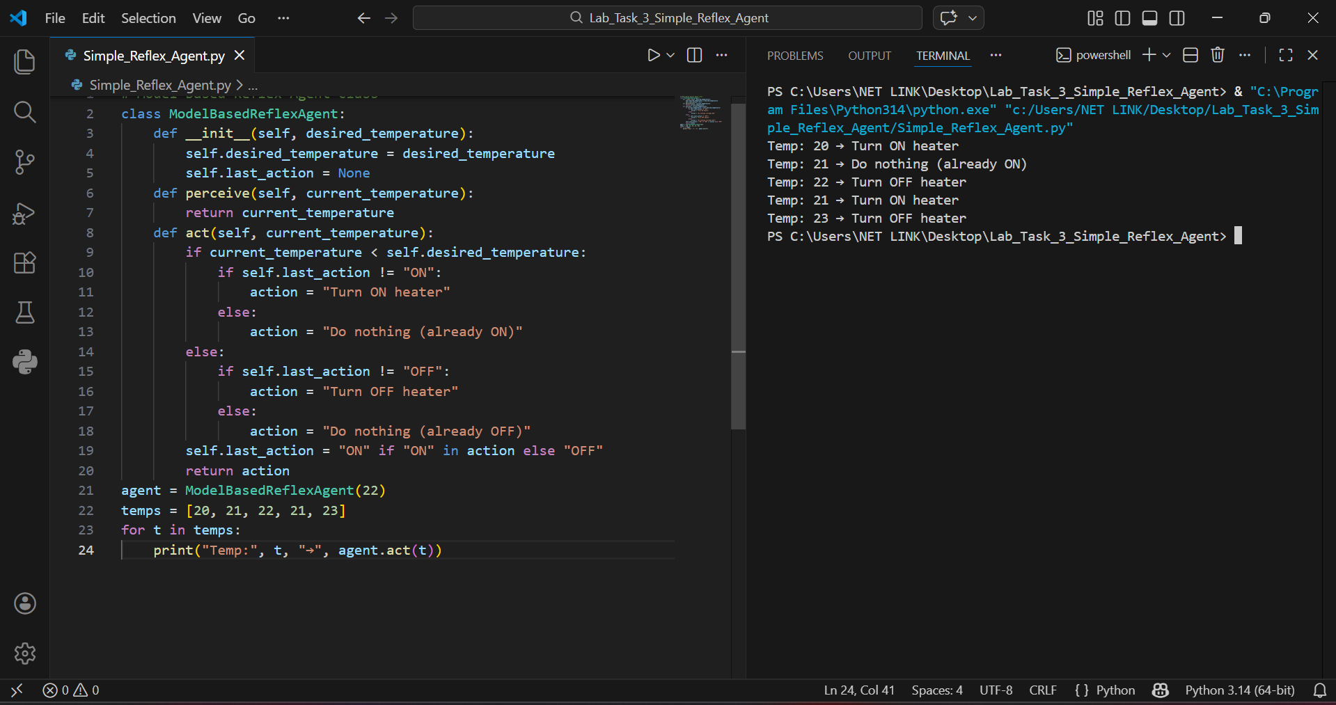

Details
This Python program is a simple Model-Based Reflex Agent using Object-Oriented Programming (OOP).
It simulates a heater control system that makes smart decisions based on:
• Current temperature
• Previous action (memory)
The agent avoids turning the heater ON/OFF unnecessarily.
The program runs in the terminal.

Main Components
• Class: ModelBasedReflexAgent
• Attributes:
- Self.desired_temperature → Target temperature
- Self.last_action → Stores previous heater action
• Methods:
- perceive() → Takes current temperature
- act() → Decides whether to turn heater ON or OFF
• Loop: Iterates through temperature values to simulate environment

How the Program Works

1. Start
• The program creates an object of the ModelBasedReflexAgent class.
• Desired temperature is set (e.g., 22°C).
• The previous action is initially set to None.

2. Perception
• The agent receives the current temperature from the environment.
• This simulates real-world temperature sensing.

3. Decision Making
• If temperature is less than desired → Heater should turn ON.
• If temperature is equal or greater → Heater should turn OFF.

4. Memory Usage (Model-Based Behavior)
• The agent remembers its last action using self.last_action.
• Before changing state, it checks:
- Was the heater already ON?
- Was the heater already OFF?
• If same state → No action taken (avoids unnecessary switching).

5. Action Output
• The agent prints decisions like:
- Turn ON heater
- Turn OFF heater
- Do nothing (already ON/OFF)

6. Simulation Loop
• A list of temperatures is used.
• The loop sends each temperature to the agent.
• The agent prints output for each value.

